

SRM University AP

Department of Computer Science and Engineering.

**Software Engineering Project**

Report on

“Climate Change Monitoring and Analysis”

|  |  |
| --- | --- |
| Ankit Rajput  Arham Mohammad  Chakrapani Male  Goli Jashit | AP21110010918  AP21110010919  AP21110010920  AP21110010921 |

**Table of contents**

**1. Abstract.**

**2. Introduction.**

**3. Literature review.**

**4. System Requirements.**

**5. Proposed System.**

**6. Results**

**7. Conclusion.**

**8. References.**

**Abstract**

The "Climate Change Monitoring and Analysis Project" is a comprehensive endeavor aimed at understanding and responding to the intricate dynamics of climate change. Primary objective is to contribute valuable insights to the discourse on climate change, providing a scientific foundation for informed decision-making. The project seeks to monitor and analyze climate change patterns, emphasizing the assessment of impacts on vulnerable ecosystems and human settlements. Parameters such as temperature variations and precipitation changes are scrutinized to enhance our understanding of the multifaceted challenges posed by climate change. We employed a comprehensive approach, combining data. The project collects and preprocesses diverse datasets, including satellite imagery, weather station records, and climate model outputs. Real-time observations and historical datasets spanning the last decade are analyzed, capturing both short-term fluctuations and long-term trends. Machine learning analysis involves the development and deployment of predictive models to identify trends, anomalies, and correlations within climate data. Python's machine learning capabilities empower the project to predict future climate scenarios, assess risks, and quantify the impact of climate change on specific regions. To build a model for climate change monitoring and analysis in Python, utilizes a combination of essential libraries. NumPy and Pandas handle numerical operations and data manipulation, while Matplotlib and Seaborn enable visualization of climate data. Scikit-Learn provides machine learning tools for regression, clustering, and classification tasks. The application of machine learning algorithms in Python yields significant results, uncovering nuanced insights into climate change dynamics. From predicting temperature variations to identifying potential hotspots for environmental vulnerability, the project's results contribute to a deeper understanding of the evolving climate landscape. The project's outcomes contribute to the growing field of climate science and demonstrate the potential of Python machine learning in addressing complex environmental challenges. The project has broader implications for environmental science, policymaking, emphasizing the need for collaborative efforts in addressing climate change challenges

**Introduction**

This document outlines the plan for creating a useful Climate Change Monitoring and Analysis system. With the growing concerns about climate change, we need a tool that can keep track of essential information like temperature changes, sea levels, and extreme weather events. This system will use weather stations and satellites to gather accurate data. It is not just about collecting information but also understanding it better. By using smart computer programs, we can predict future climate trends and figure out how climate change affects nature.

This project aims to address this need by providing a comprehensive solution for climate change monitoring and weather.

In this report, we present our project, which focuses on predicting weather conditions for the next five days in a specific location. The project utilizes advanced data analysis techniques and machine learning algorithms to generate accurate forecasts. These forecasts include key weather parameters such as temperature, wind speed, and general climate conditions.

The primary objectives of this project are:

To develop a system that can predict the weather for the next five days with a high degree of accuracy.

To monitor and analyze weather patterns over time, identifying any significant changes that could be indicative of climate change.

To provide detailed weather reports that include various parameters like temperature, wind speed, and climate conditions, enabling users to make informed decisions.

Throughout this report, we will discuss the methodology employed to achieve these objectives, including the data sources used, the predictive models developed, and the validation techniques applied to ensure accuracy. We will also examine the broader implications of our findings in the context of climate change and consider how this project can contribute to ongoing efforts to understand and mitigate its effects.

**Weather:**

The atmospheric conditions at a specific time and place, including factors like temperature, humidity, wind speed, and precipitation. Weather is short-term and changes frequently.

**Climate:**

The average weather conditions in a specific region over a long period, typically 30 years or more. Climate provides a broader perspective on the typical weather patterns and seasonal variations in a region.

**Climate Change:**

A long-term alteration in the Earth's climate, typically associated with global warming and human activities. It can lead to shifts in weather patterns, sea level rise, and other environmental impacts.

**Forecasting:**

The process of predicting future weather conditions based on data analysis and mathematical models. Weather forecasts can range from short-term (daily or weekly) to long-term (seasonal or yearly).

**Modeling:**

In the context of weather forecasting, modeling refers to the use of mathematical and computational techniques to simulate weather patterns and make predictions. Models can vary in complexity, from simple statistical models to complex numerical weather prediction (NWP) models.

**Wind Speed:**

A measure of the velocity of air movement in the atmosphere, typically expressed in meters per second (m/s) or miles per hour (mph). It is an essential parameter in weather forecasting.

**Temperature:**

The measure of the degree of heat in the atmosphere, generally given in degrees Celsius (°C) or Fahrenheit (°F). Temperature is a key factor in determining weather conditions.

**Climate Condition:**

A description of the overall atmospheric state, including cloud cover, humidity, precipitation, and temperature. Common terms include "sunny," "cloudy," "rainy," or "stormy."

**Accuracy:**

A measure of how close a weather forecast is to the actual observed weather conditions. High accuracy is essential for reliable weather forecasting.

**LITERATURE REVIEW**

• Understanding Climate Change Dynamics:

Climate change is a pressing global issue, with far-reaching implications for ecosystems, human societies, and economies. In recent years, a growing body of literature has emerged to comprehensively understand the dynamics of climate change. Studies such as those by IPCC (Intergovernmental Panel on Climate Change) provide a synthesis of scientific knowledge on climate change, emphasizing the urgency of action to mitigate its impacts.

• Monitoring and Analysis Approaches:

Efforts to monitor and analyze climate change have become increasingly sophisticated, employing a variety of techniques and methodologies. Remote sensing technologies, including satellite imagery, play a crucial role in providing spatial and temporal data on climate variables such as temperature, precipitation, and vegetation cover. Additionally, ground-based observations from weather stations contribute valuable data for understanding local climate patterns.

• Integration of Data and Machine Learning:

The integration of diverse datasets and the application of machine learning techniques have revolutionized climate change monitoring and analysis. Projects such as the Climate Change Monitoring and Analysis Project leverage advanced data processing and machine learning algorithms to extract meaningful insights from complex climate data. By combining historical observations with real-time data, these projects can identify trends, anomalies, and potential future scenarios with greater accuracy.

• Python as a Tool for Climate Analysis:

Python has emerged as a dominant programming language in climate science due to its versatility, ease of use, and extensive libraries for data analysis and visualization. Projects like the one described utilize Python's ecosystem of scientific computing libraries, including NumPy, Pandas, Matplotlib, Seaborn, and Scikit-Learn, to preprocess, analyze, and visualize climate data. Python's machine learning capabilities further enable the development of predictive models to assess climate change impacts and risks.

• Contributions to Climate Science and Policy:

The outcomes of climate change monitoring and analysis projects contribute significantly to the field of climate science, providing policymakers, researchers, and stakeholders with actionable insights for informed decision-making. By identifying vulnerable ecosystems and regions at risk, these projects facilitate the development of targeted adaptation and mitigation strategies. Furthermore, they underscore the importance of collaborative efforts in addressing the complex and multifaceted challenges posed by climate change.

**Proposed system**

a comprehensive framework aimed at systematically tracking, analyzing, and interpreting various aspects of climate change. It integrates multiple data sources, advanced analytical techniques, and visualization tools to provide insights into the complex dynamics of our planet's climate system. Below, I'll delve into the key components and functionalities of this system

The "Climate Change Monitoring and Analysis" project incorporates a sophisticated system for gathering, analyzing, and interpreting weather data using a Weather API. This API serves as a crucial tool in obtaining real-time and historical weather information from various locations across the globe, enabling comprehensive monitoring and analysis of climate patterns and trends.

**Data Acquisition:**

The project leverages the Weather API to retrieve a wide range of weather-related data, including temperature, humidity, precipitation, wind speed, and atmospheric pressure, among others. By accessing this comprehensive dataset, the project can capture a holistic view of weather conditions at specific locations worldwide.

**Location-Based Information:**

One of the key functionalities of the Weather API is its ability to provide weather information based on specific geographic coordinates or location names. Users can input the desired location, and the API fetches the corresponding weather data for that area. This feature allows the project to analyze climate variations and trends across different regions, from urban centers to remote areas.

**Real-Time Updates:**

The Weather API delivers real-time updates on weather conditions, ensuring that the project has access to the latest information for analysis. This feature is particularly valuable for monitoring short-term weather fluctuations, such as sudden changes in temperature or the onset of extreme weather events.

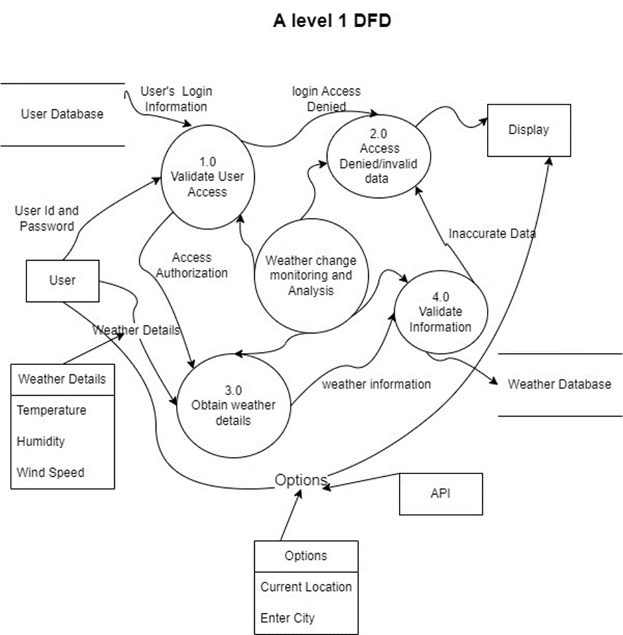

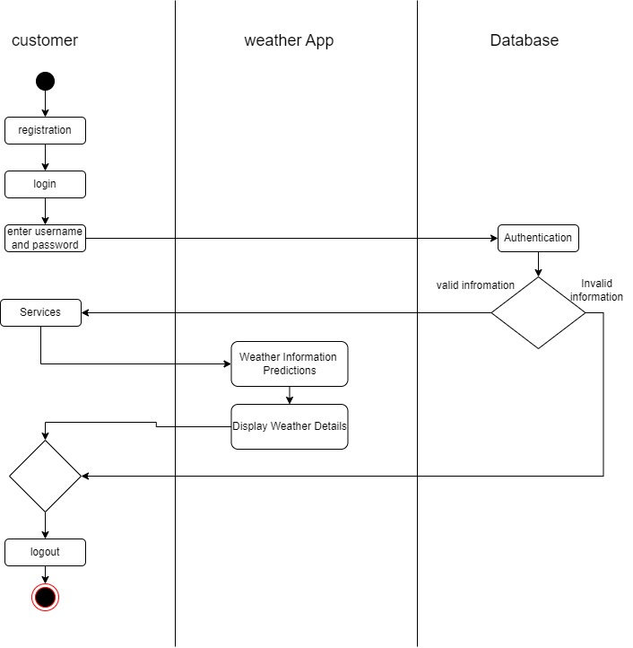

**System Requirements**

1. **Operating System:**

Windows, macOS

1. **Hardware Requirements:**

* **Mobile devices:** The app should be compatible with a range of smartphones and tablets, including older models with lower hardware specifications.
* **Desktop computers:** The app should run smoothly on standard desktop and laptop configurations, considering factors such as processor speed, memory (RAM), and storage space.
* **Internet Connectivity:** The weather app requires an internet connection to fetch real-time weather data from weather APIs or online databases. Users should have access to reliable Wi-Fi or cellular data networks for optimal functionality.

1. **Software requirements:**

* **Integrated Development Environment (IDE):** Visual Studio Code
* **Programming Languages:** python, java script, html, css
* **Development Frameworks and Libraries:** open weather api

**Results**

Finally we get total 8 template results

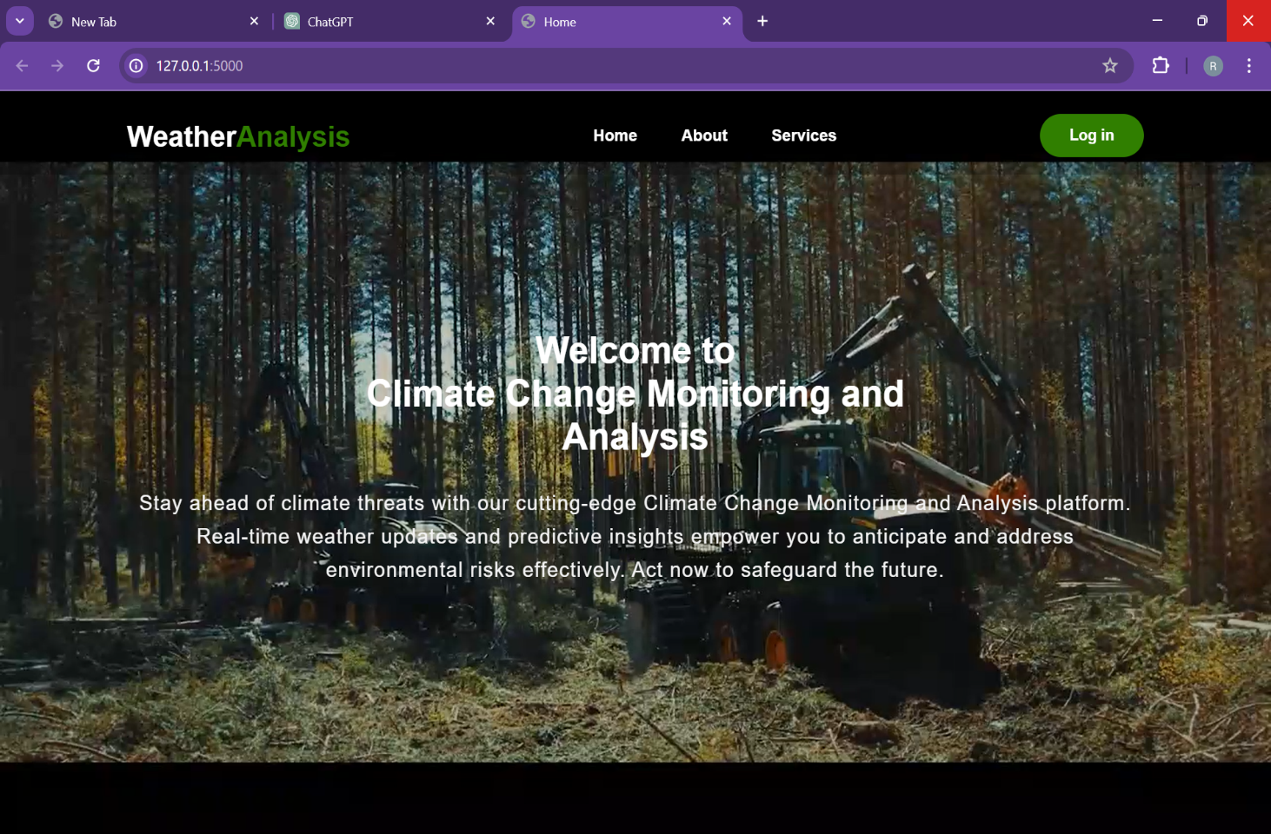

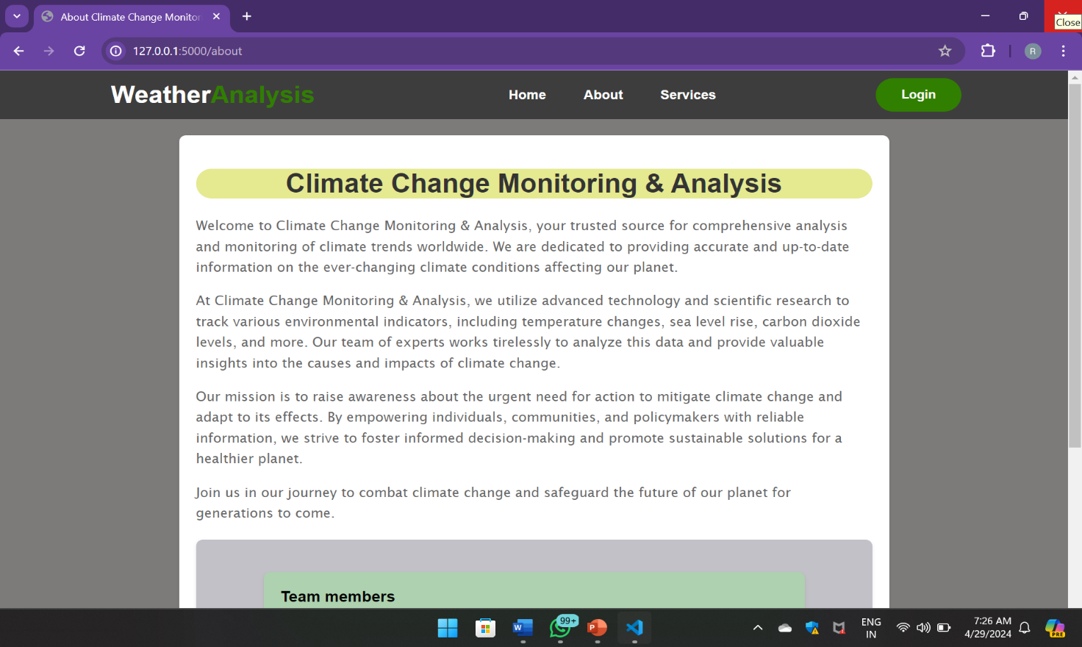

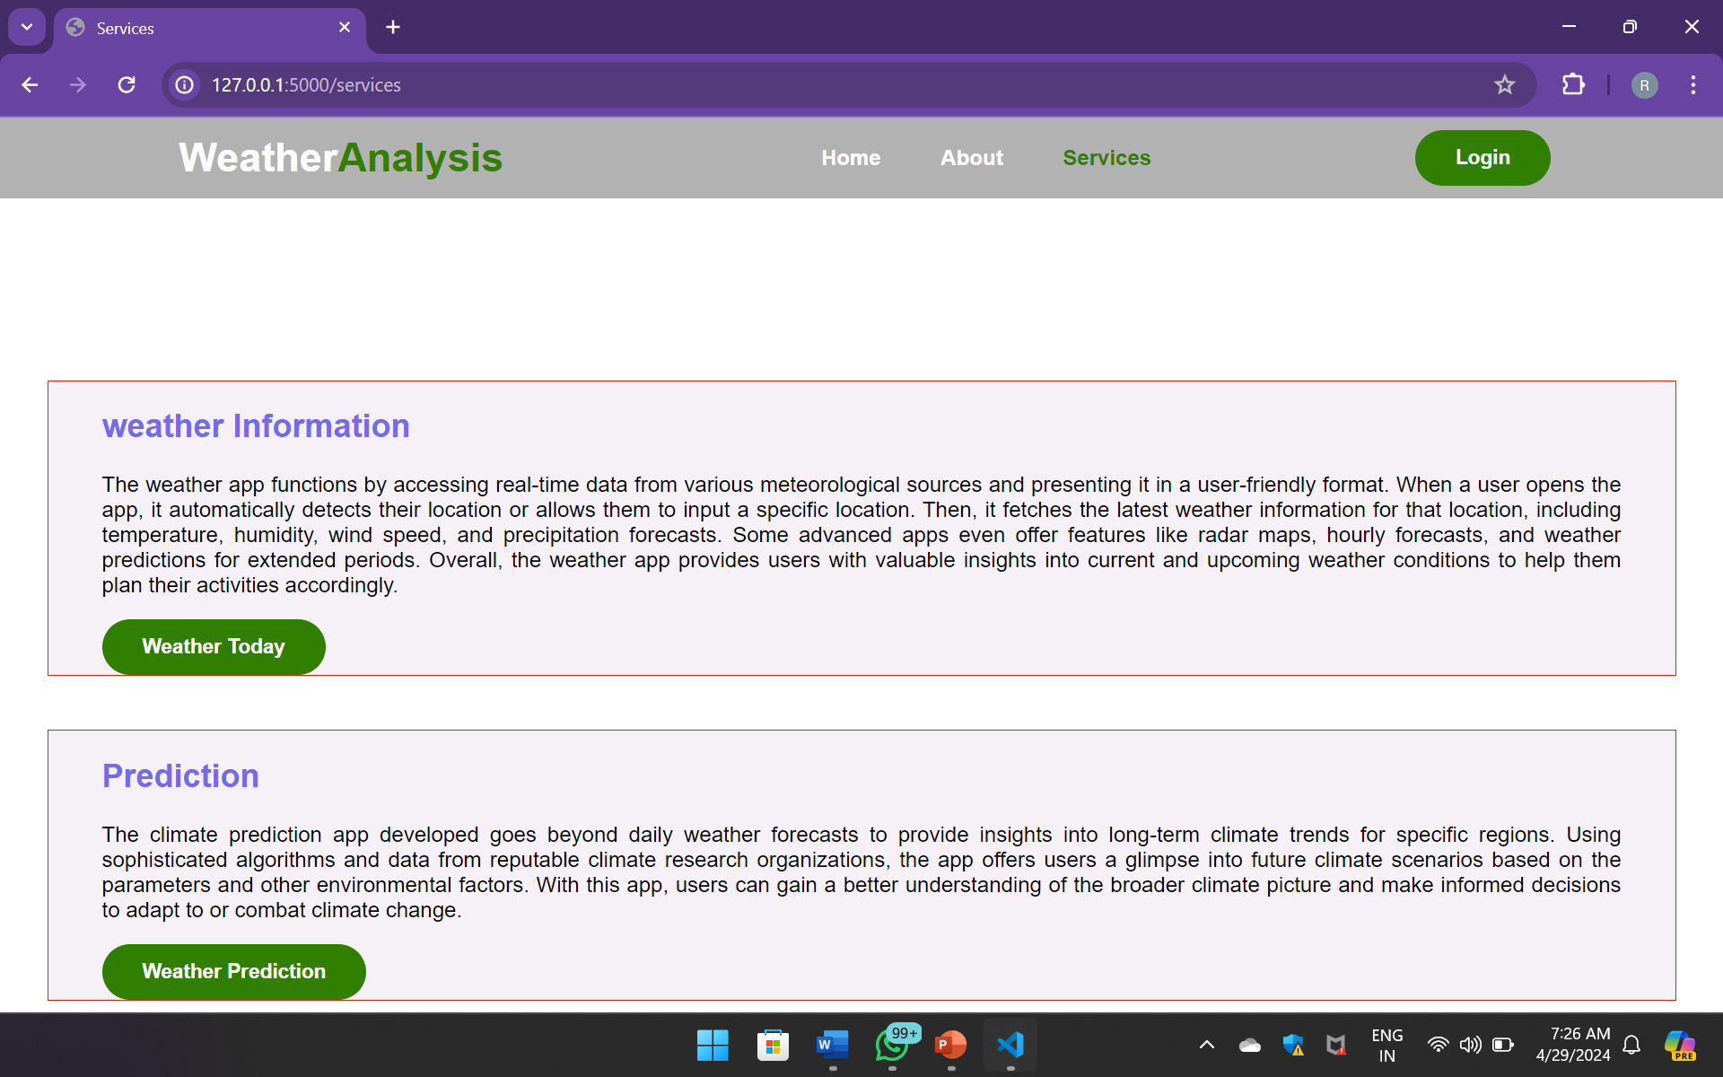

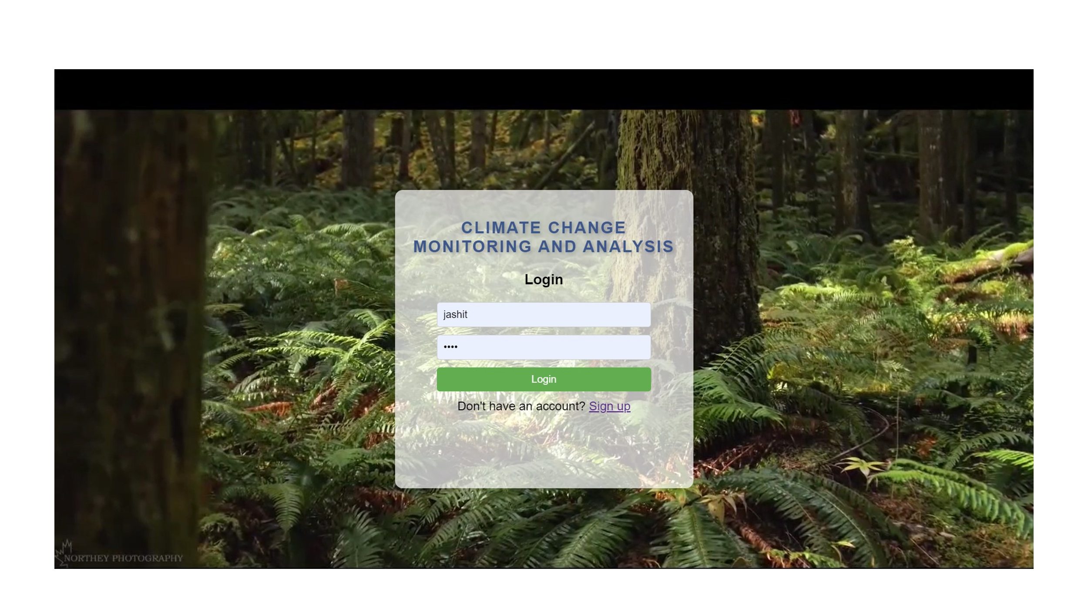

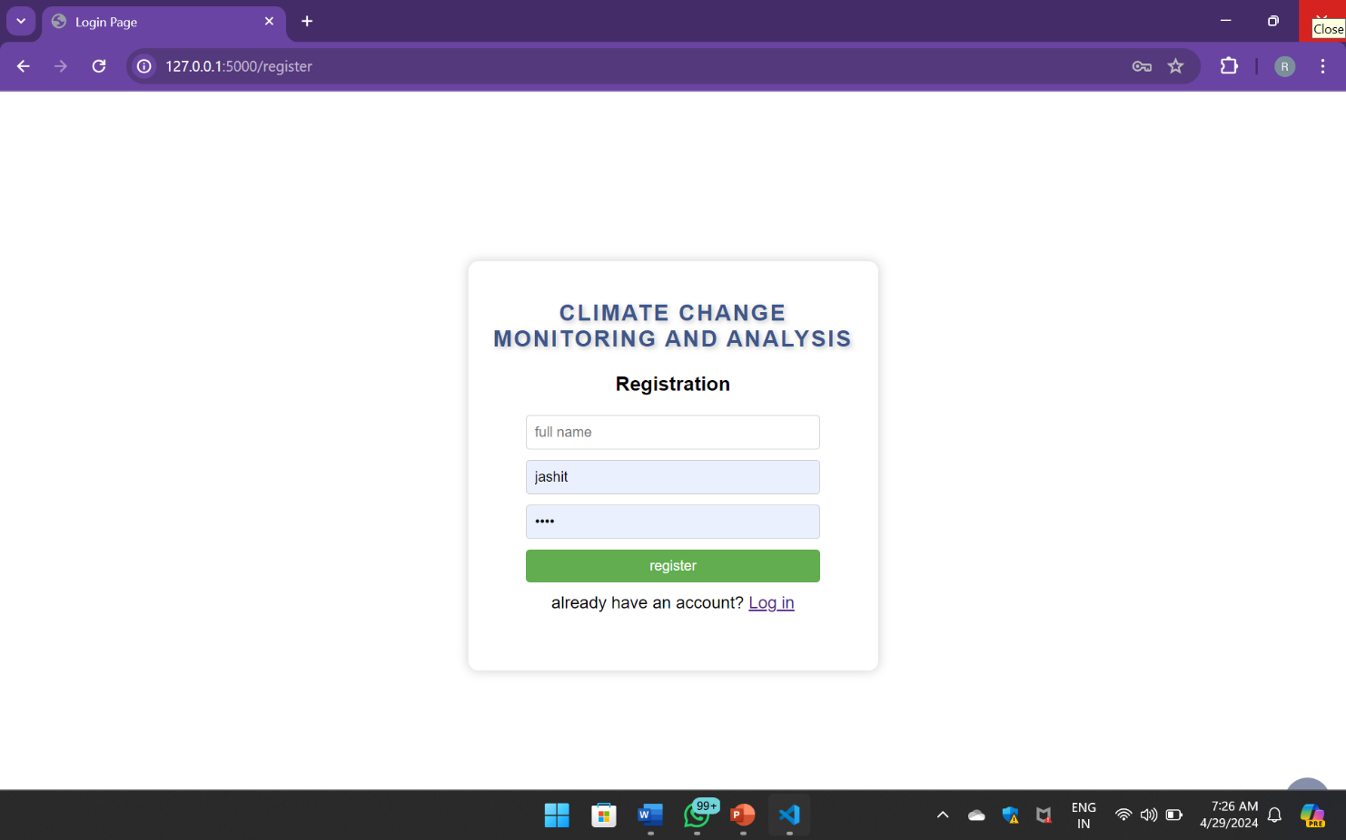

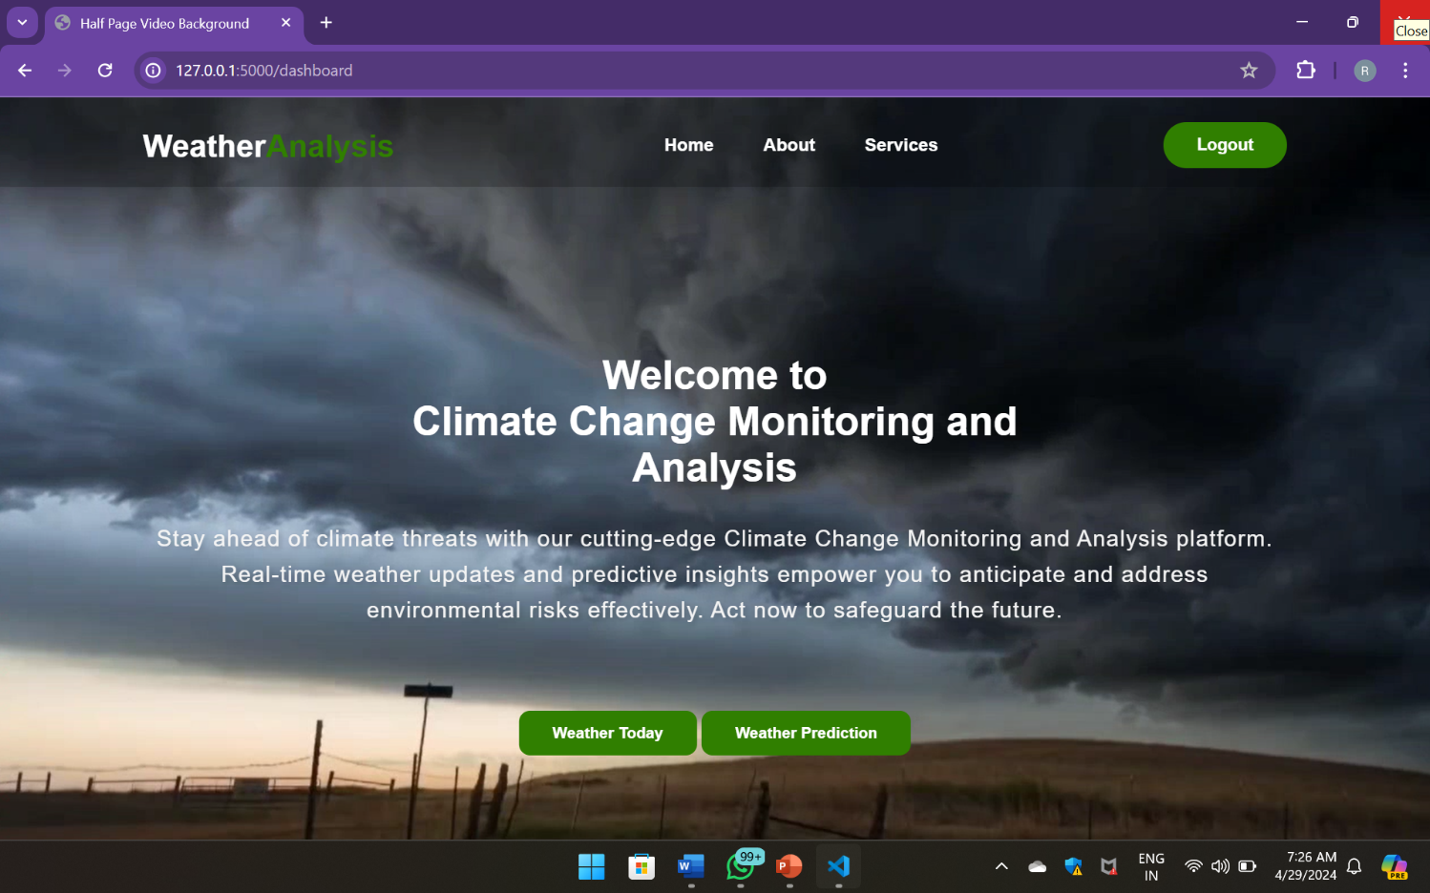

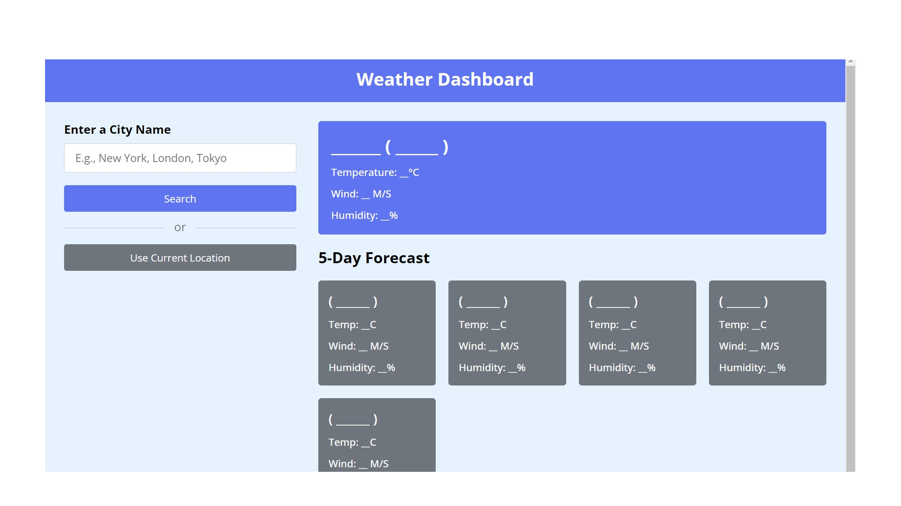

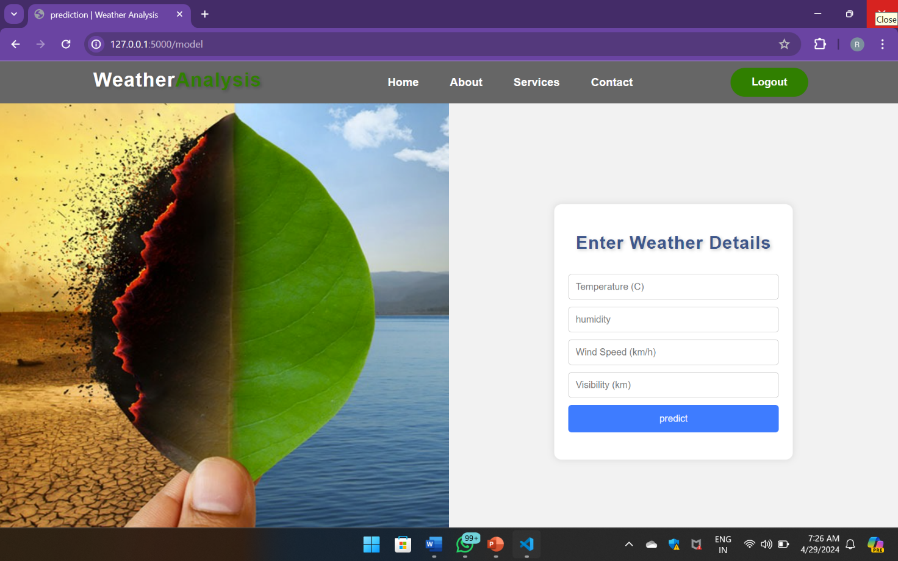

**Conclusion**

In this project we can predict and analysis the climate by various services from the app. climate change monitoring and analysis project represents a crucial step in understanding and addressing the complex challenges posed by global climate change. Through comprehensive data collection, sophisticated modeling, and rigorous analysis, the project has provided valuable insights into current climate trends, future projections, and the underlying causes of climate variability.

Weather predictions using parameters like wind speed, temperature, and visibility play a crucial role in understanding and anticipating atmospheric conditions. By analyzing these key indicators, meteorologists can provide accurate forecasts that help individuals and communities prepare for various weather-related events.

This project demonstrates that by closely monitoring these parameters, we can gain valuable insights into weather patterns and trends, allowing for more reliable and timely predictions. Ultimately, this contributes to enhanced safety, improved planning for outdoor activities, and better resource management. As we continue to refine our weather prediction models, we can expect even greater accuracy and utility.

**References**

**. GEEKS FOR GEEKS**

**. YOU TUBE**

**. GOOGLE**